1. 03/20/2023, 04:20pm, <https://www.bilibili.com/video/BV1dP4y1c7qd/?p=134&spm_id_from=pageDriver&vd_source=bc40910ac8881fceed42763281af0f89>
2. 本来这个文档是接着newssystem里面的Note写的，但是感觉不管代码还是文档都会破坏newssystem的完整性，于是重新开始在这个文件里面写；Note会重新复制一份放到newsystem的github上面；
3. Graphical user interface, text, application, email

   Description automatically generated GraphQL是Facebook开发的一种数据查询语言，是REST API的替代品；Text

   Description automatically generated with medium confidence 并不是非他不可，只是可以大大减少开发和维护的成本；Graphical user interface, text, application

   Description automatically generated
4. 【P134-09】在这里，首先后端要支持GraphQL的查询，之后前端想要什么数据，那就是前端自己按需索取，但前提是后端也得改造成GraphQL的方式；后端怎么写呢？后端也是基于Node.js开发的；【P134-14】express是一款非常方便的帮助我们创建web应用的框架；
5. Diagram

   Description automatically generated 【P134-09】引入express的目的，希望大家能快速的基于express创建出几个路由/接口，这样的话咱们直接请求接口就可以；第三句是引入graphql模块，第二句是链接express和graphql的模块；需要把这三个模块都下载下来；Text

   Description automatically generatedDiagram

   Description automatically generated var schema这句是为了定义好查询的语句和类型；Graphical user interface, diagram, application

   Description automatically generatedText

   Description automatically generatedGraphical user interface, application

   Description automatically generated
6. Graphical user interface, text

   Description automatically generated npx nodemon;
7. Graphical user interface, text, application

   Description automatically generated 【P135-01】参数类型与传递，基本类型和数组；Text

   Description automatically generatedGraphical user interface, text, application

   Description automatically generated 上面写的都是基本数据类型，哪怕是数组也是单一的类型，如果我们想查询复杂的数据类型怎么办呢？比如想查询一个账户中的用户名，年龄，等不同数据类型的数据，那就需要我们自定义类型，比如Text

   Description automatically generatedText

   Description automatically generated 注意type Account 和type Query后面都是直接大括号；Graphical user interface, text, application

   Description automatically generatedText

   Description automatically generatedText

   Description automatically generatedGraphical user interface, text, application

   Description automatically generatedText

   Description automatically generated 【P135-14】Text

   Description automatically generated
8. Text

   Description automatically generated with low confidenceA picture containing text

   Description automatically generatedGraphical user interface, application

   Description automatically generated
9. Graphical user interface, text, application, email, website

   Description automatically generated 【P136】修改数据使用Mutation; 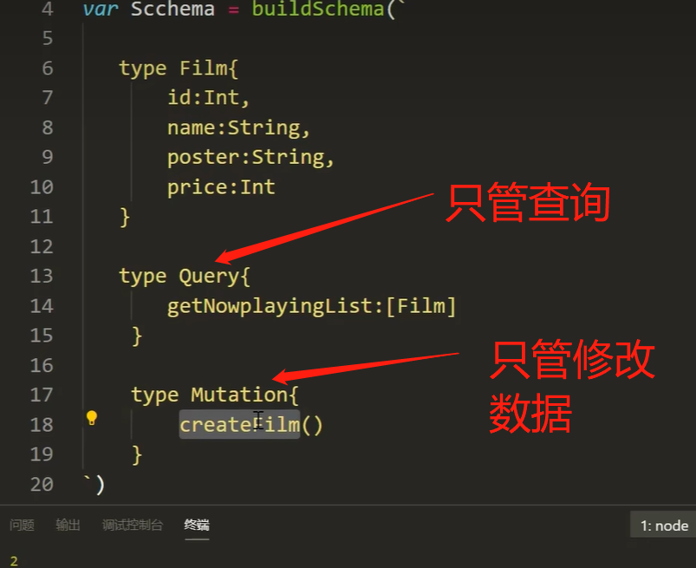Text

   Description automatically generated 【P136-04】
10. Mutation步骤，【P136-09】Graphical user interface, text, application

    Description automatically generatedGraphical user interface, text, application

    Description automatically generatedA picture containing graphical user interface

    Description automatically generated
11. Text

    Description automatically generated 创建和更新数据都写在Mutation中；Text

    Description automatically generatedGraphical user interface, application

    Description automatically generatedGraphical user interface, text, application

    Description automatically generated
12. 删除数据：A picture containing text

    Description automatically generated 【P136-16】Text

    Description automatically generated with medium confidenceGraphical user interface, text, application

    Description automatically generatedGraphical user interface, application, Word

    Description automatically generated
13. 安装MongoDB；Graphical user interface, text, application, email

    Description automatically generated 官网直接下载的；
14. 如何启动MongoDB呢，首先在我们本地文件的目录下创建一个文件夹db, Graphical user interface, application, Word

    Description automatically generated 获取这个文件夹所在的路径，然后进入到安装MongoDB的目录的bin文件夹中，打开cmd终端，输入如下Text

    Description automatically generated with medium confidence 参考这个安装连接<https://www.jianshu.com/p/ff36429c100d> Text

    Description automatically generated 127.0.0.1:27017; **注意这个cmd不能关掉**，然后Graphical user interface, text

    Description automatically generated 写上这句代码，重启服务器，
15. Graphical user interface, text, application, Word, email

    Description automatically generated 本来想下载的是这个软件robomongo 0.9.0, 最后链接转来转去下载的是这样的Graphical user interface, text, application

    Description automatically generated <https://studio3t.com/download-studio3t-free/>
16. Graphical user interface, text, application, Word

    Description automatically generated 密码是123456789.
17. 因为千峰kerwin那里mongodb我这边没法用，找啊找啊找啊，换成了这个教程<https://www.bilibili.com/video/BV1EE411e7zB/?p=9&spm_id_from=pageDriver&vd_source=bc40910ac8881fceed42763281af0f89> ，然后需要安装mysql, (我最开始以为应该是mysq workbench)最终按照这个网页安装了mysql, 其中包含了mysql workbench <https://blog.csdn.net/qq_59636442/article/details/123058454> ,然后再打开mysql workbench接着看这个视频<https://www.bilibili.com/video/BV1PY411b7Y2/?spm_id_from=333.337.search-card.all.click&vd_source=bc40910ac8881fceed42763281af0f89> 不对，其实是上面找到的另一个教程，也是千峰的；数据库密码是123456789；Graphical user interface, application

    Description automatically generated
18. 接下来请继续参考这个视频<https://www.bilibili.com/video/BV1EE411e7zB/?p=9&spm_id_from=pageDriver&vd_source=bc40910ac8881fceed42763281af0f89> A picture containing application

    Description automatically generated
19. Mysql完结，时间03/23/2023, 05:43pm;